**Romans Pizza Spin App**

[**https://github.com/MarcoMeyer1/roman-pizza-spin-challenge**](https://github.com/MarcoMeyer1/roman-pizza-spin-challenge)

**Main Spin Screen**

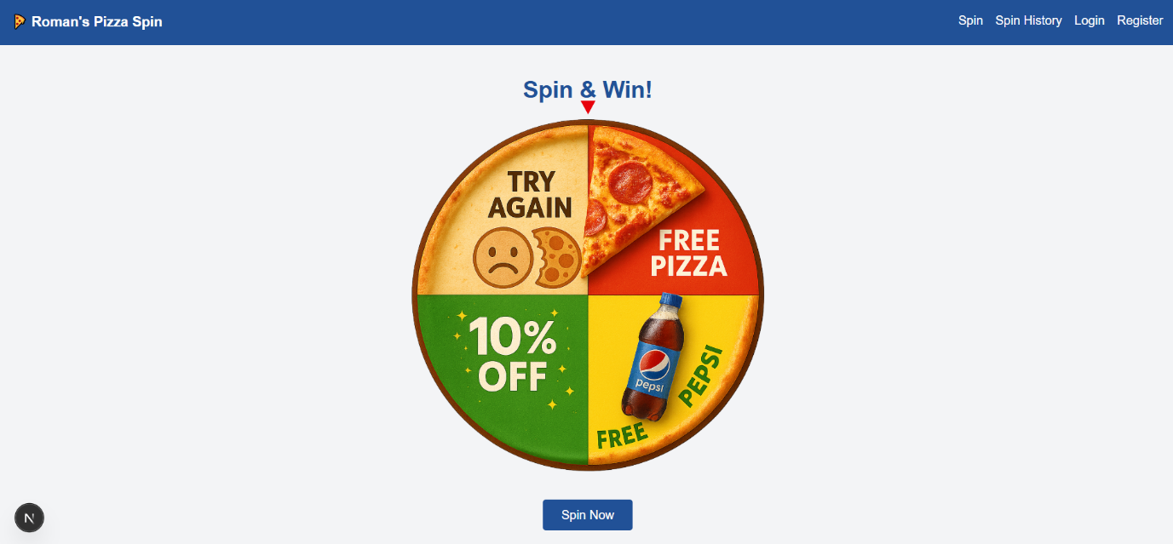The user-facing homepage features the spinning wheel interface. Logged-in users can spin to win a random prize. Access is restricted to authenticated users only.

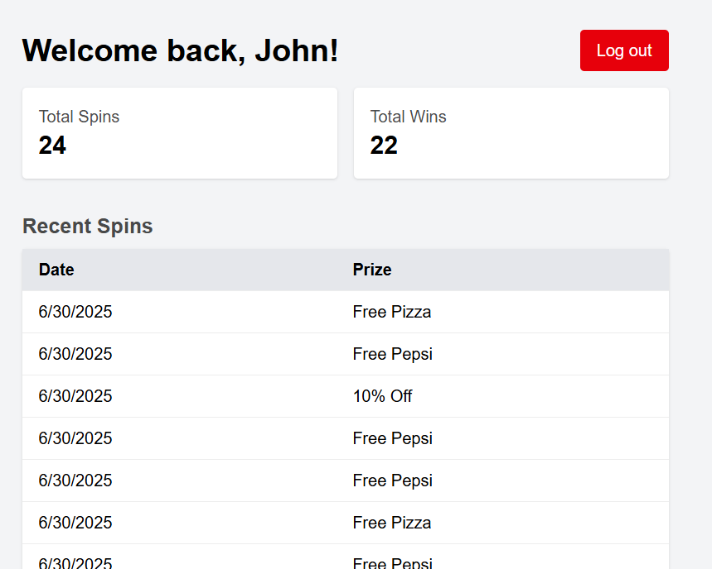

**Spin History Dashboard**

After logging in, users can view a personalized dashboard showing their total spins, total wins, and recent spin results. User data is stored locally using localStorage.

**Supabase customers Table**

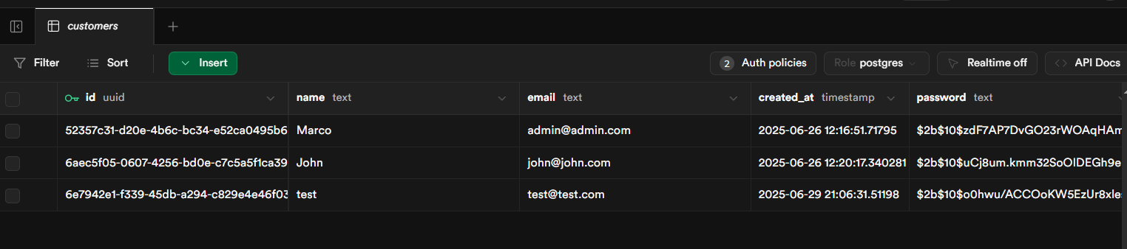Stores registered user data including name, email, password (hashed), and created_at. Primary key is id (UUID).

**Supabase spins Table**

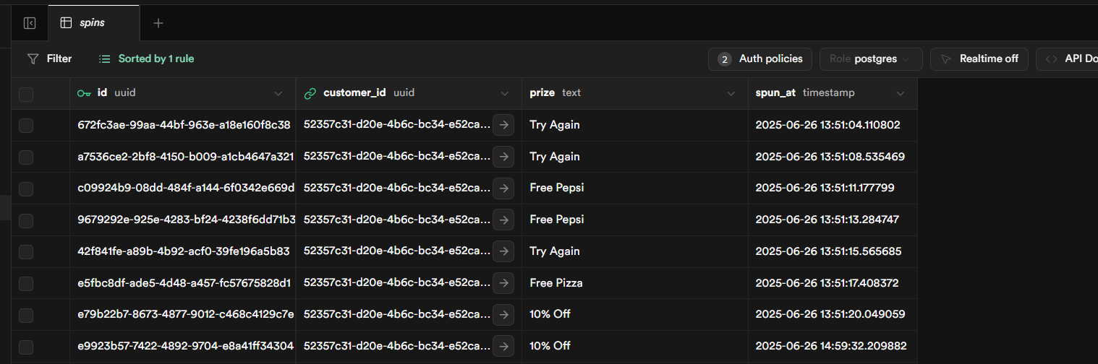Records each spin attempt, storing the customer_id (foreign key), prize outcome, and timestamp. Linked to the customers table via customer_id.

**Database Schema & Relationships**

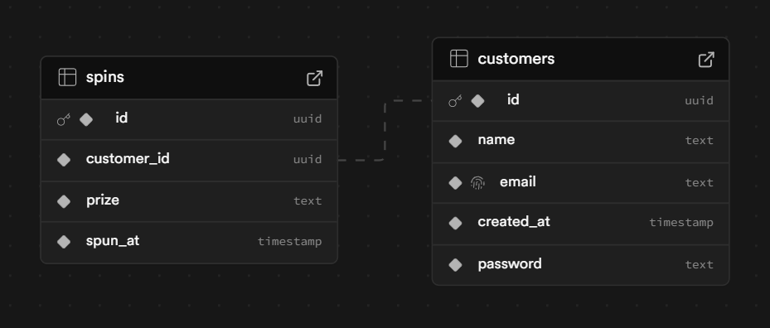A visual ERD showing the relationship between the customers and spins tables. Each spin is tied to a single customer using a UUID foreign key.

**Auth Policies**

Row-level security (RLS) is enabled. API requests are securely handled through Supabase and custom endpoints for registration, login, and spin recording

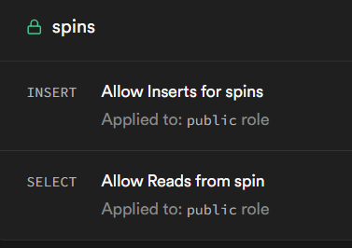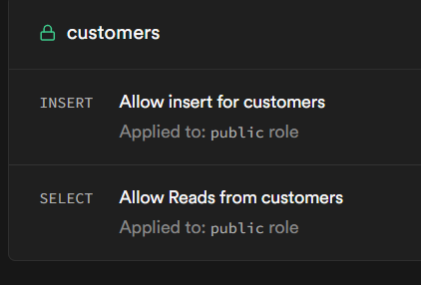

**GitHub Commit History**

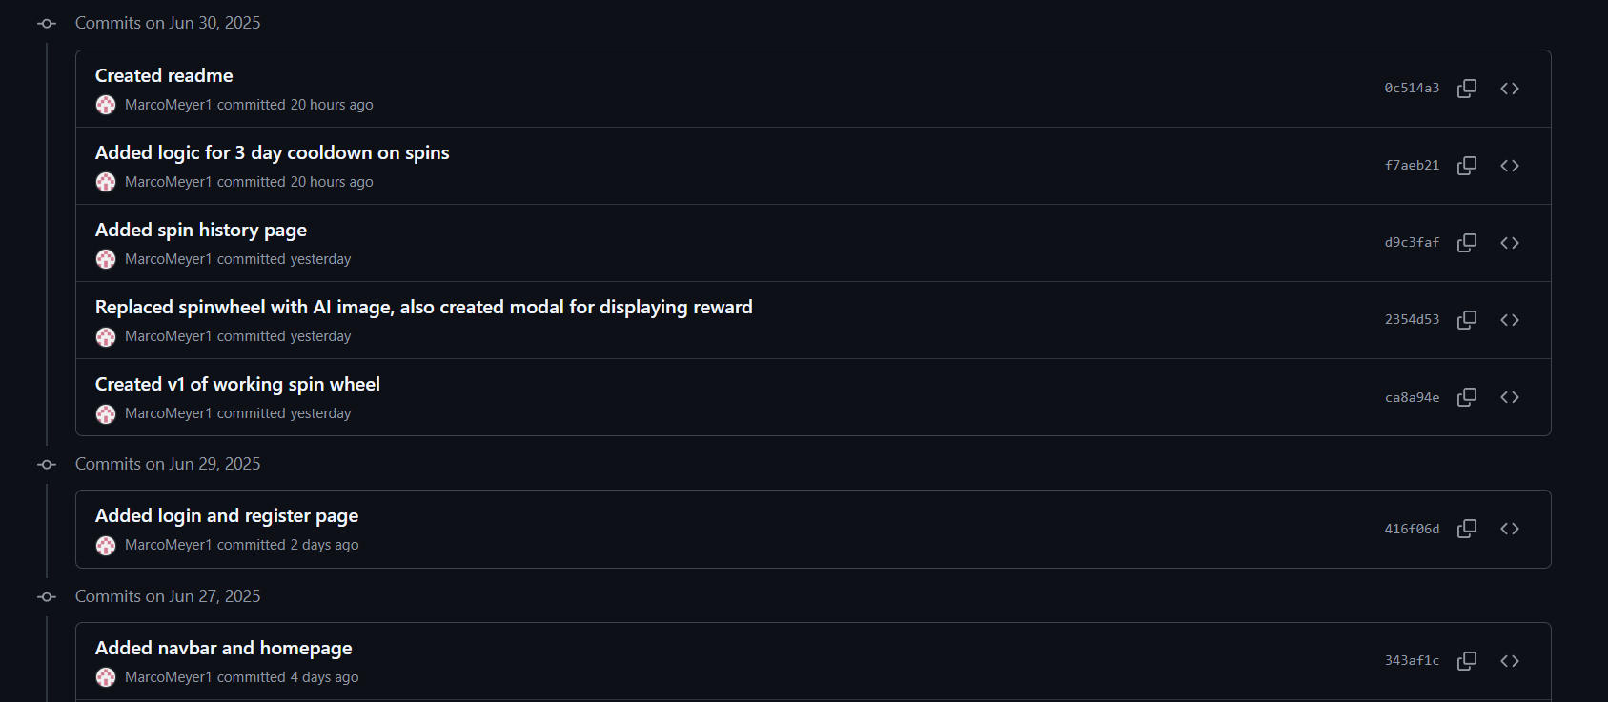This image shows some of the project's GitHub commit log, documenting the incremental development of the app.

**Personal Notes:**

* I included a password field during user registration for added realism. For simplicity, the passwords are the same as the usernames.

For example:

* + admin@admin.com → Password: admin
  + john@john.com → Password: john
* You’ll notice the .env file is committed to the GitHub repository. I fully understand this is very discouraged and the security risks, but I’ve included it to simplify running and testing the application on your end without requiring additional setup.
* I also implemented a **3-day cooldown** between spins to simulate a real-world promotional limitation. However, for testing purposes, this cooldown can be toggled off via the ENABLE_COOLDOWN flag in the frontend (SpinWheel.js, line 12).